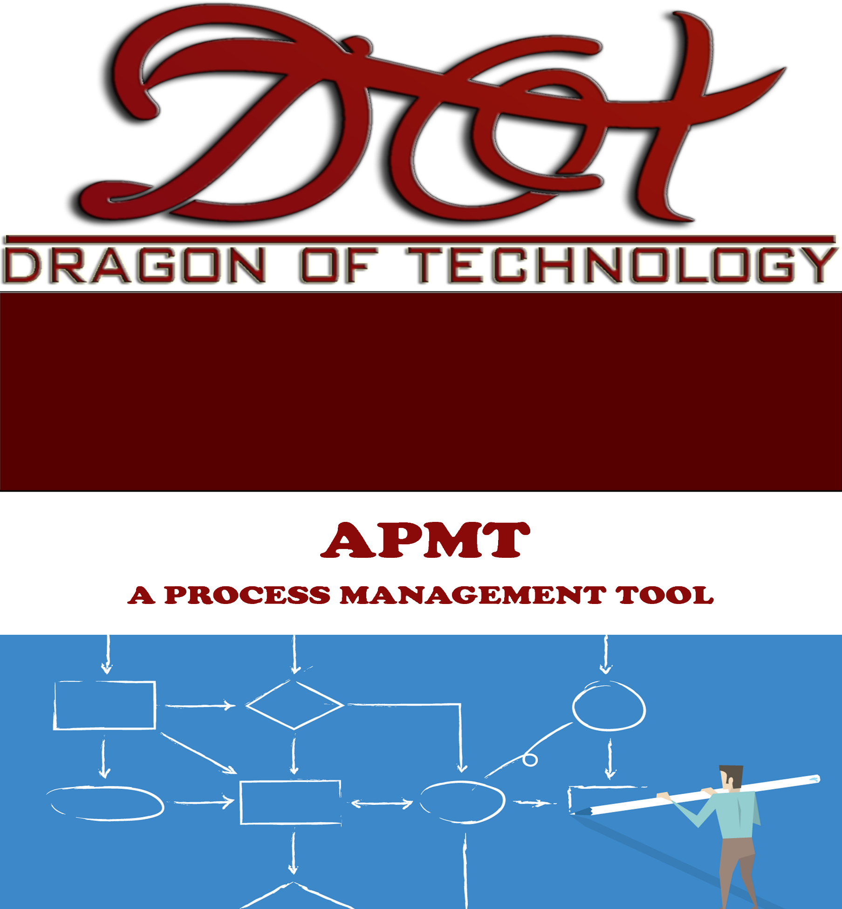

CONFIGURATION MANAGEMENT

PLAN

**Revision History**

|  |  |  |  |  |
| --- | --- | --- | --- | --- |
| **Version** | **Date** | **Author** | **Editor** | **Content** |
| 1.0 | 04/10/2016 | Luan Cu | Quang Du | Content Number 1,2 |
| 1.1 | 04/10/2016 | Luan Cu | Luan Cu | Update |

**DoT Team members**

1. **Lê Công Thắng**
2. **Cù Minh Luân**
3. **Du Kim Quang**
4. **Nguyễn Trọng Nghĩa**
5. **Mai Phước Hưng**
6. **Lưu Quang Minh**
7. **Lê Minh Quân**

**Table of Contents**

**1.** **Introduction** 3

**1.1.** **Purpose** 4

**1.2.** **Audience** 4

**2.** **Configuration Management** 4

**2.1.** **Organization** 4

**2.2.** **Training** 5

**3.** **Configuration Activities** 5

**3.1.** **Configuration Items** 5

**3.2.** **Configuration Identification** 5

**3.2.1.** **Document Name** 5

**3.2.2.** **Document Content** 6

**3.2.2.1.** **Prescribed for Word documents** 6

**3.2.2.2.** **Prescribed for Excel documents** 7

**3.2.3.** **Tool for access to the repository** 7

**3.2.3.1.** **Source Code Repository** 7

**3.2.3.2.** **Manage Files Repository** 7

**3.2.4.** **Tool for team management, track bugs, assign task** 7

**3.2.5.** **Tool for editing documents** 8

**3.2.6.** **Tool for product development** 8

**3.2.7.** **Tool and Organizing folder to store document** 8

**3.3.** **Artifact Life Cycle** 8

**3.4.** **Configuration Control** 9

**4.** **Glossary** 10

**5.** **References** 10

**LIST OF TABLES**

Table 1. Configuration Items 5

Table 3. Document standard 7

Table 4. Prescribed for excel documents 7

Table 5. Repository 7

Table 6. Tool for team management, track bugs, assign task 8

Table 7. Folder organization 8

Table 8. Artifact life cycle 9

Table 9. Glossary 10

1. **Introduction**
   1. **Purpose**

The purpose of the Configuration Management Plan is to describe how configuration management (CM) will be conducted throughout the project lifecycle. This includes documenting how CM is managed, roles and responsibilities, how configuration item (CI) changes are made, and communicating all aspects of CM to project stakeholders.

* 1. **Audience**
* **Configuration Control Board (CCB)**

The CCB is comprised of the Product Owner, Scrum Master for the configuration item (CI) under consideration. The CCB is responsible for the following:

* Review and approve/reject configuration change requests
* Ensure all approved changes are added to the configuration management database (CMDB)
* Seeking clarification on any CIs as required
* **Product Owner**

The Product Owner is responsible for:

* Providing approval for any issues requiring additional scope, time, or cost
* **Scrum Master**  
  The Scrum Master is responsible for:
* Overall responsibility for all CM activities related to the APMT project
* Identification of CIs
* All communication of CM activities to project stakeholders
* Participation in CCB meetings
* Re-baselining, if necessary, any items affected by CM changes

1. **Configuration Management**
   1. **Organization**

The APMT Project configuration management will be involved in configuration management activities.

**Responsibility of configuration management:** Because DoT team is a big team (sevenn members). It’s the responsibility of all team members to follow the flow in this document in order to preserve the integrity, traceability and modifiability of all artifacts in the software configuration. Maintenance of this configuration itself is also a responsibility of all team members of the DoT team.

**General guideline**

* When creating documents or making changes, follow these general guideline to prevent collisions:
* If you are not sure about the name of a new file or the directory where it should be saved, ask the configuration manager in the team. Most artifacts should follow a naming convention. If you create a new file, check in this document if there is a convention that applies.
* Not all artifacts produced during the software development project should be under configuration management. Files created as an intermediate step to the creation of an artifact should not be copied into the depot, even if these files are shared among team members. If we put under configuration management every file we create, the depot we’ll get cluttered. Use your best judgment here.
* Many artifacts will be Word documents such as this plan. They all should use the same visual style and basic structure. Use the template available and avoid formatting paragraphs—use the styles available in the template.
* Some artifacts will be PowerPoint presentations. For any studio-related presentation, use the PowerPoint template available
  1. **Training**
* Microsoft Visio and Enterprise Architect for draw use case and detail design
* Bug tracker for tracking bugs and changes
* Use GitHub for integrating source code

1. **Configuration Activities**
   1. **Configuration Items**

|  |  |  |
| --- | --- | --- |
| **No.** | **Category** | **Item** |
| 1 | **Document** | Document name |
| Document content (font, size, table, header, footer, bullets, margins) |
| Symbols for drawing process |
| 2 | **Process** | Process make changes document on DoT GitHub |
| Process submit document to repository |
| 3 | **Tool** | Tool for access to the repository |
| Tool for tracking bugs |
| Tools for editing documents. |
| Tools for product development |
| 4 | **Organization** | Organize folders to store document |

Table 1. Configuration Items

* 1. **Configuration Identification**
     1. **Document Name**

**<Name of document> = <TeamName>_<ProcessName>_< DocumentName> _<Version>**

E.g.: Name of configuration management plan documents of WMS project: **D.o.T_APMT_ConfigurationManagementPlan_Ver1.0.doc**

**Additional information:** Naming rules for meeting minute and time log:

* Meeting minute:
  + Meeting with customer:

**D.o.T_APMT_MeetingMinutes_Cus_<ddmmyy>**

* + Meeting with mentor:

**D.o.T_APMT_MeetingMinutes_Mentor_<ddmmyy>**

* + Meeting with team:

**D.o.T_APMT_MeetingMinutes_Team_< ddmmyy>**

* Timelog:

**D.o.T_APMT_TimeLog_<Firstname><LastName>**

* Project Status Report:

**D.o.T_APMT _WeeklyReport_Week##**

(E.g.D.o.T_APMT _WeeklyReport_Week14)

* Member Evalution:

**D.o.T_APMT _MemberEvalution _Week##**

(E.g.D.o.T_APMT_MemberEvalution_Week14)

* + 1. **Document Content**
       1. **Prescribed for Word documents**

|  |  |
| --- | --- |
| **Component** | **Regulations** |
| **Font** | Arial, text size: 12 |
| **Type** | * Title: * Size 36 * Font style: Bold * Font color: Red (Custom: Color model: RGB, Red: 153, Green: 0, Blue: 0) * Header level 1: * Size 16 * Font style: Bold * Font color: Red (Custom: Color model: RGB, Red: 153, Green: 0, Blue: 0) * Header level 2 * Size 14 * Font style: Bold * Font color: Black * Header level 3 * Size 12 * Font style: Bold * Font color: Black * Header level 4 * Size 12 * Font style: Bold * Font color: Black |
| **Table** | * Column header: * Fill color: Color code: Red (Custom: Color model: RGB, Red: 153, Green: 0, Blue: 0) * Size: 11 * Font color: White * Position: Align left * Cell: * Fill color: No color * Size: 11 * Font color: black |
| **Header** | As header of this document |
| **Footer** | As footer of this document |
| **Bullet** | Optional |
| **Margin** | Left: 1 inch, Right: 1 inch, Top: 1 inch, Bottom: 1 inch |

Table 3. Document standard

* + - 1. **Prescribed for Excel documents**

|  |  |
| --- | --- |
| **Component** | **Regulations** |
| **Font** | Arial |
| **Column header** | Fill color (background): Color: Red (Custom: Color model: RGB, Red: 153, Green: 0, Blue: 0), Size: 11  Font color: White  Position: Align left |
| **Cell** | Fill color (background): Color White, Size: 11  Font color: Automatic |

Table 4. Prescribed for excel documents

**Note:** Apply the order of time for all document: dd/mm/yyyy

* + 1. **Tool for access to the repository** 
       1. **Source Code Repository**

|  |  |
| --- | --- |
| **Criteria** | **Description** |
| Name | GitHub |
| URL | https://github.com/minhluan95/CapstoneProject_DotTeam_ManageSourceCode |
| Username | kimquang1995  quanminhle1995  nghianguyent133981  MaiPhuocHung  LeCongThang  luuquangminh  minhluan95 |

Table 5. Repository

* + - 1. **Manage Files Repository**

|  |  |
| --- | --- |
| **Criteria** | **Description** |
| Name | GitHub |
| URL | https://github.com/minhluan95/CapstoneProject_DotTeam_ManageFiles |
| Username | kimquang1995  quanminhle1995  nghianguyent133981  MaiPhuocHung  LeCongThang  luuquangminh  minhluan95 |

* + 1. **Tool for team management, track bugs, assign task**

|  |  |
| --- | --- |
| **Criteria** | **Description** |
| Name | Trello.com |
| URL | https://trello.com/capstoneproject28 |
| Username | kimquang1995  quanminhle1995  nghianguyent133981  MaiPhuocHung  LeCongThang  luuquangminh  minhluan95 |

Table 6. Tool for team management, track bugs, assign task

* + 1. **Tool for editing documents**

|  |  |
| --- | --- |
| **Name** | **Description** |
| Microsoft Office | 2013 |
| Microsoft Visio | 2013 |
| Enterprise Architect | 7.1 |
| Rational Rose | 7.0 |

* + 1. **Tool for product development**
* Microsoft Visual Studio 2015
* SQL Server 2012
  + 1. **Tool and Organizing folder to store document**

**GitHub Folder Structure of D.oT Team**

|  |  |  |
| --- | --- | --- |
| **Root folder** | **Subfolder** | **Description** |
| 1. **Kick-off** | None |  |
| 1. **Planning and Process Document** | 1.1. Project Management | Contains documents about plan for project management in all phase of the project |
| 1.2. Quality Management |
| 1.3. Architecture |
| 1.4. Implementation |
| 1.5. Testing |
| 1. **Artifact and Deliverables** | 2.1 . Architecture & Design  2.2. Training  2.3 . Code  2.4 Testing |  |
| 1. **Meeting Minutes** | 3.1. With Customer | Contains meeting minutes documents of the project |
| 3.2. With Mentor |
| 3.3. With Team |
| 1. **Monitoring and Tracking** | 4.1.Individual Time log  4.2.Project Status Report | Contains documents for plan each week and tracking project |
| 1. **Team Reflection** | None |  |
| 1. **Presentation** | None |  |
| 1. **DoT Team** | 8.1 Logo Team  8.2 CoverPage Word |  |

Table 7. Folder organization

* 1. **Artifact Life Cycle**

|  |  |  |  |
| --- | --- | --- | --- |
| **No.** | **Configuration Item** | **Start** | **End** |
| 1 | Document name | Applied throughout entire process | |
| 2 | Document content (font, size, table, header, footer, bullets, margins) | Applied throughout entire process | |
| 3 | Symbols for drawing process | Requirement phase | |
| 4 | Process make changes document on DoT GitHub | Applied throughout entire process | |
| 5 | Process submit document to repository | Applied throughout entire process | |
| 6 | Tool for access to the repository | Applied throughout entire process | |
| 7 | Tool for tracking bugs | Applied throughout entire process | |
| 8 | Tools for editing documents. | Applied throughout entire process | |
| 9 | Tools for product development | Test phase | Implement phase |
| 10 | Organize folders to store document | Applied throughout entire process | |

Table 8. Artifact life cycle

* 1. **Configuration Control**

**Make a change or modification**

When a team members need to make a change, he/she should observe the following rules. If there is some other opinions, that opinion can be argued in daily meeting.

* If the modification happens at the level of adding and updating files, the team member can proceed to the modification with notifying configuration manager.
* If the modification happens at the level of modifying the directory structure under configuration management, the team member should consult with configuration manager.
* If the modification happens at the level of modifying overall configurations, the team member should request to configuration manager and hold a meeting for discussing the issues.

**Version control**

All artifacts should be version-controlled.

The members of DoT team should observe the guidelines below with respect to version control:

**With document**:

* If user A modifies a file X and commit it to GitHub , he/she should ask if another user made change to file X. if there is no one who made change to file X, then A can submit the file X.

**With source code:**

* If user wants to create a file and submit to GitHub , user does not have to submit all folders and file bin or obj and just submit the file that modified or created
* If user wants to modify a file, user must ask who keep the file. If no one keep file, user can notify the others. Files of source code that submitted in GitHub must be build succeed.

1. **Glossary**

|  |  |  |
| --- | --- | --- |
| **No.** | **Glossary** | **Description** |
| **1.** | CCB | Configuration control board |
| **2.** | CM | Configuration management |
| **3.** | CI | Configuration item |
| **4.** | CMDB | Configuration management database |
| **5.** | PMO | Program management office |

Table 9. Glossary

1. **References**

K15T Capstone document